Presentation Brief

Statement: Create a 5-minute presentation on a real-life problem you have noticed. Critically think about the problem and propose a plan of action.
Your presentation will be based on VISUALS. Find relevant visuals like advertisements, artworks, memes, photographs, or short video clips. When you present, talk about why you chose these visuals and what they mean. (If you choose ads or video clips, you can only choose 1 and it must NOT be more than 45 seconds).

This presentation will test your critical thinking and communication skills. For critical thinking, your problem-solving is the key factor. For communication skills, how you incorporate visuals to communicate a stance is important.

Here is what your presentation should have:
- A real-life problem
- An appropriate and catchy title for the presentation
- Problem analysis-
  - what is it, what are the causes, how is it impacting the world/people?
  - Cite credible sources
- The proposed plan of action
  - Proper plan- Do not suggest that the government should solve it, or someone should magically resolve the problem.
- VISUALS to support your stance. Have enough visuals that can be discussed in under 5 minutes.

Here’s what NOT to do:
- Write too much content on slides. This is a VISUAL presentation.
- Time it poorly, have it too brief or too long
- Use AI-generated content/images. You will be analyzing the images, so make sure you know what they mean.
- Bring something inappropriate. Ensure that your content is appropriate for class, be it memes, advertisements, short clips, or anything else. (In case you have suspicions, check it with your instructor before presenting it in class)

Suggested themes:
Here are some themes that you can use for your presentation. You may pick another topic that is not mentioned below.

- The current state of Gaza and the failure of humanity
- Poverty
- Hidden struggles that are underestimated
- Mental health and stigma
- Education system
- Dysfunctional families
- Moral corruption through the entertainment industry
- Humanitarian crisis
- The misuse of power
- The danger of controlled narrative

Here’s a sample:

Theme: Poverty
Presentation Title: “If you’re homeless, just buy a house” and other smart solutions
Problem under analysis: Homelessness
Visual example:
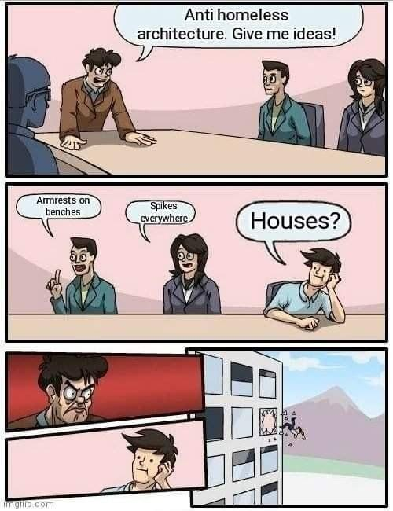
Image analysis:
- How the meme template contributes to the idea that homelessness is a man-made problem, and the relevant authorities do not wish to eradicate the problem.
- Explain how the meme works: the person with the actual solution gets thrown out of the window because it is NOT an acceptable solution.
- For the rich to be richer, the poor must be poorer- the capitalist system operates on this and therefore, poverty must remain.
- Anti-homeless architecture and its implications: class divide, ignorance, insensitivity to others’ suffering, and the power of narratives in creating this suffering. Say, why is Anti-homeless architecture even a thing?

Note: this is just a sample that explains the process of image analysis a bit. That’s one part of your presentation. Utilize your critical thinking skills and create a presentation using presentation tools. Remember, you will be talking about the topic, so you will not need to write what you can explain.

